Shonan Meeting #51

**Water Disaster Management and Big Data**

2014 July 7-10

<http://www.nii.ac.jp/shonan/blog/2013/01/27/water-disaster-management-and-big-data/>

**Organizers**

* Fang-Pang Lin, National Center for High-performance Computing (NCHC), National Applied Research Laboratory, Taiwan
* Satoshi Sekiguchi, National Institute for Advanced Industrial Science and Engineering (AIST), Japan
* Philip Papadopoulos, University of California San Diego (UCSD), USA
* Shinji Shimojo, Osaka University and National Institute for Information and Communications Technology (NICT), Japan
* Yoshio Tanaka, National Institute for Advanced Industrial Science and Engineering (AIST), Japan

**Sponsors**

* National Institute for Information (NII) Japan
* Kanagawa Prefecture, Japan

**Background for Meeting**

* Over the 12 years of PRAGMA (2002 – 2014, member institutions had experienced several types of disasters: typhoon damages (annually in Taiwan – in particular Nock-ten October 2004, Morakot August 2009), flooding (Thailand 2011, Australia), earthquake/tsunami (March 11, 2011 tsunami that affected Japan), and fires (October 2003 and 2007 affecting San Diego).
* At the PRAGMA 21 Workshop, sponsored by GEO Grid – supported by MEXT Japan, organized by AIST, co-organized by Osaka U, Titech, and U Tsukuba, with many other sponsors(see <http://pragma21.pragma-grid.net/dct/page/1>) there was a special session on GEO Grid and a focus on this in the PRAGMA 21 Workshop. In discussions, the keynote speaker Kenzo Hiroki (ICHARM) was asked the question
  + If you could have (or improve) one technology in handling a disaster, what would that be?
  + His response was: Have a technology where he could have all of the (distributed) people responding to information focus, simultaneously, on the same piece of information (e.g., video or data feed).
  + His presentation and the ensuing discussion stayed with the participants for many years.
* Given the nature of PRAGMA, to delve more deeply into how to address this concern (and other concerns around disaster management), we knew we needed to have an extended, dedicated time for discussions between disaster management and IT experts. The Shonan venue gave us that opportunity.
* A proposal to Shonan was first discussed at Supercomputing November 2012 (Salt Lake City). It was decided then to focus on water disaster management, both to allow us to make progress, but also to reflect the issues that motivated the organizers. A proposal was finally submitted in 2013, and accepted in December 2013.

Broader Community Interest

In parallel to PRAGMA’s journey to this meeting, the larger community, within countries and internationally, saw needs to address issues around the entire disaster management cycle. One most relevant to this workshop is

National Research Council. *Improving Disaster Management: The Role of IT in Mitigation, Preparedness, Response, and Recovery*. Washington, DC: The National Academies Press, 2007. <http://www.nap.edu/catalog.php?record_id=11824>

See other references below.

**Key observations** from the meeting (some of these were stated at the meeting, others are based on reflection of meeting discussions)

* Disasters are not confined to national boundaries. Learning how to effectively manage them is an opportunity to share effective practices and approaches in an international setting
* Disaster management (including all four phases – see below) is an extremely complex operation, requiring collaborations among many expertise and ultimately among many agencies.
* Ability to access and process data, often real time, is critical to “improve” managing disasters.
* There are major opportunities for and need of information technology most phases of disaster management. While the NRC report cited above covers many of these challenges, technology has continued to evolve. One technology that offers opportunities and challenges is social media. The opportunity is the ability to connect with people and expand the “sensing” and “real time data” into managing disasters (both data in and data out). On the other hand, there is a great deal to learn about validating such information and how all participants should understand these data.
  + A statement from one of the references indicated that in none disaster scenarios, much effort is put into ensuring technologies and approaches are efficient; however in the cases of disasters we need solutions that are scalable and resilient
  + Currently, most academic resource providers do not think/test about backing up services (like they have learned to back up data)
* There are key assumptions that underpin many scenarios: namely that there is communications and power.
* In thinking about responding to disasters, one needs to “define” success. This could be saving lives or saving some particular lives, protecting property, …
* While we did not dwell on this, there are potentially disruptive technologies / disruption deployments in the future
  + Ubiquitous communications
  + UAVs for data gathering, available for rapid deployment
  + Tiling tablets for shared visualization

**Phases in Disaster Management**

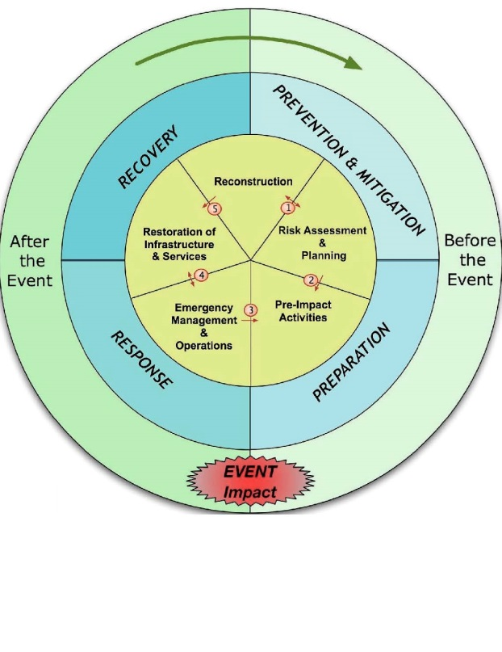From Earthzine (<http://www.earthzine.org/disaster-management-theme/>). Vanneuville et all, posted March 21, 2011 (<http://www.earthzine.org/author/Vanneuville/>) in Is ‘Flood Risk Management’ Identical to ‘Flood Disaster Management’?

**Summary of Discussions**

**The Scenarios**: The group focused early in the meeting on three motivating type of disasters:

* Flooding: This can result from typhoons as well as ongoing and frequent monsoons. The image many participants had was the flooding in Thailand in 2011.
* Tsunami: The image participants had was of the devastating Tsunami that struck Japan in March 2011. In addition there was a severe Tsunami that hit Aceh Indonesia in 2004.
* Typhoon: These affect the region, from the Philippines (most recently November 2013 with Typhoon Haiyan) to Typhoon Morakot (August 2009; <http://en.wikipedia.org/wiki/Typhoon_Morakot>) that created conditions that created a mudslide that buried a village), to others that affect Japan, Korea and China.

There are commonalities among the scenarios

* Need to integrate data from various sources
* Promise and challenges in social media, in getting information to and from population, and being able to have a measure of validity about data from others
* Predictions of impact of disaster are required for allocation of resources for response and recovery. Often this will require models of the natural disaster (e.g., trajectories of typhoon, predictions of rainfall).

In addition, there are differences, chief is the time scale in responding to a disaster, with the shortest possibly being tsunami, to the longest being floods. However, many factors are still difficult to predict, e.g. exact amount and location of rainfall.

**Addressing Scenarios**: Different Approaches, Different User Needs

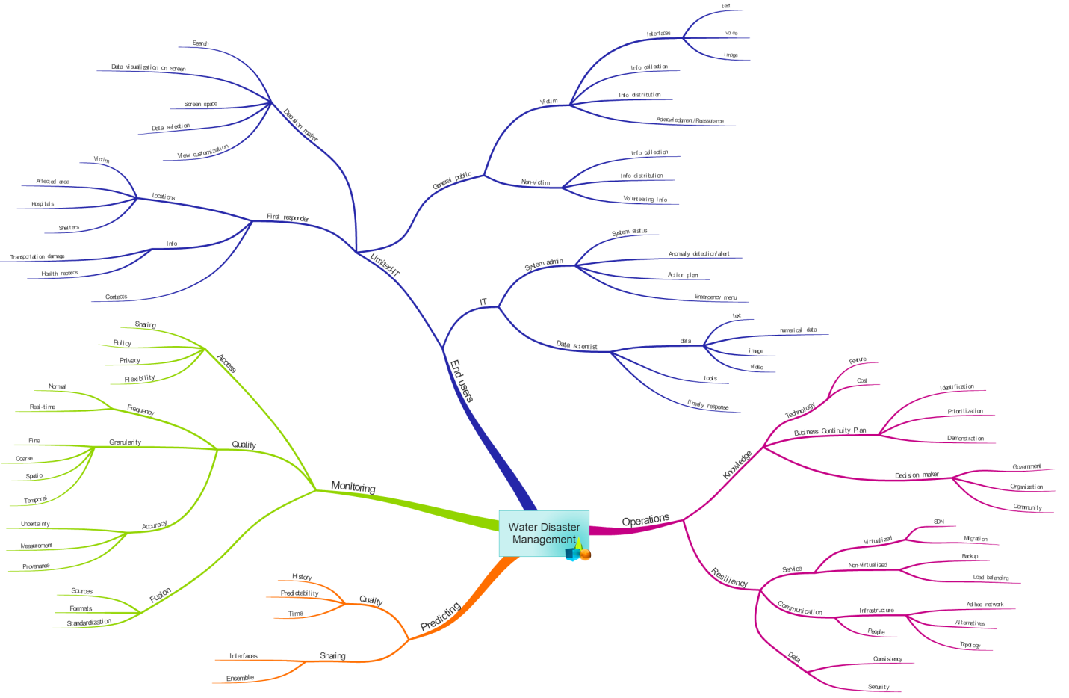This figure (using iMindMap – software to visualize information) resulted from the first breakout group session that used the three scenarios, but looked at different approaches:

* Monitoring
* Predicting
* Operations/Infrastructure

In each of these scenarios there were “user” perspectives. But even here there were different type of users

* Response Managers (needing to decide where to allocation resources)
* First responders
* Data contributors (acting as sensors for disaster response systems)
* Victims (how to get help)

This is not an exhaustive list. In some cases, there were very specific suggestions for testing pieces of approaches to determine how difficult it would be to implement some of the technologies. In particular see diagram for testing the migration of a data center.

One common theme among the approaches is data: Generating, accessing, using, and communicating.

**Specific Scenarios**: What If

To try to be more concrete about what would we focus on as subsets, after the meeting concluded, we formed three breakout groups to identify a specific scenarios problem, what if we could have or know something, and what technology might we want to use. The three scenarios are:

* Typhoon Attack: Rainfall
  + We would like better prediction of rainfall, both amounts and locations. This would allow us to better predict location of flooding, debris flow, and chances of mudslides
  + Monitoring Technology that we would use:
    - Remote sensors (Radar, UAV)
    - In-Situ (Ground based) increased coverage cameras, sensors
    - Uncontrolled sources (social media, mobile sensors)
  + Infrastructure (same order as monitor) we would want to have
    - Remote sensors: international connections networks (politics)
    - In-situ: redundancy Network, optimization, placement
    - Intelligence systems/filtering, virtualization solutions
  + Prediction Models (this was not discussed explicitly) but one would need both better (pre-calculated) models of where there are mudslide hazards, and better run-off models.
* Typhoon Attack: Communicating
  + When typhoon is coming, authority want to know the location and information of people who still struggle in the mountain area, or during disaster, the location of isolated peple
  + Assumption: Power and communication still partially work
  + Solution: Infrastructure: SDN, community network
  + Prediction: potential dangerous areas (landslide, debris flow)
  + Monitoring: not finish yet
* Flooding
  + Flooding slowly approaches to capital city
    - Where to divert water, to airport or city?
    - What information is required for decision makers
  + What if we can have
    - Virtual environment for decision making
      * Map interface sharable among decision makers
        + Where is hospital, airport, and power plant
    - Superimpose (overlap) “4D” Geo, time-referenced data
      * Decision maker must want to know the situation over time
  + Technology
    - Tile display wall, tiled tablet

**Concrete Steps**: What happens after meeting?

* There are several ways for the community to continue to develop these ideas and to “try out” some of the ideas. Two particular venues are
  + PRAGMA Workshops, with the next two planned for
    - 2014 October 15 – 17, Bloomington Indiana USA
    - 2015 April 8 – 10, Nara, Japan
  + Southeast Asia Institute program (SEAIP),
    - 2014 December 1-5, City TBD, Taiwan
* Specific Activities to be tried
  + Migrate a Data center, using specific remote sensing data (phased array radar)
  + Build collaborations between Taiwan and Japan for sharing phased array radar data (that can give more information about amount and location of rainfall – during a typhoon)
  + Other?

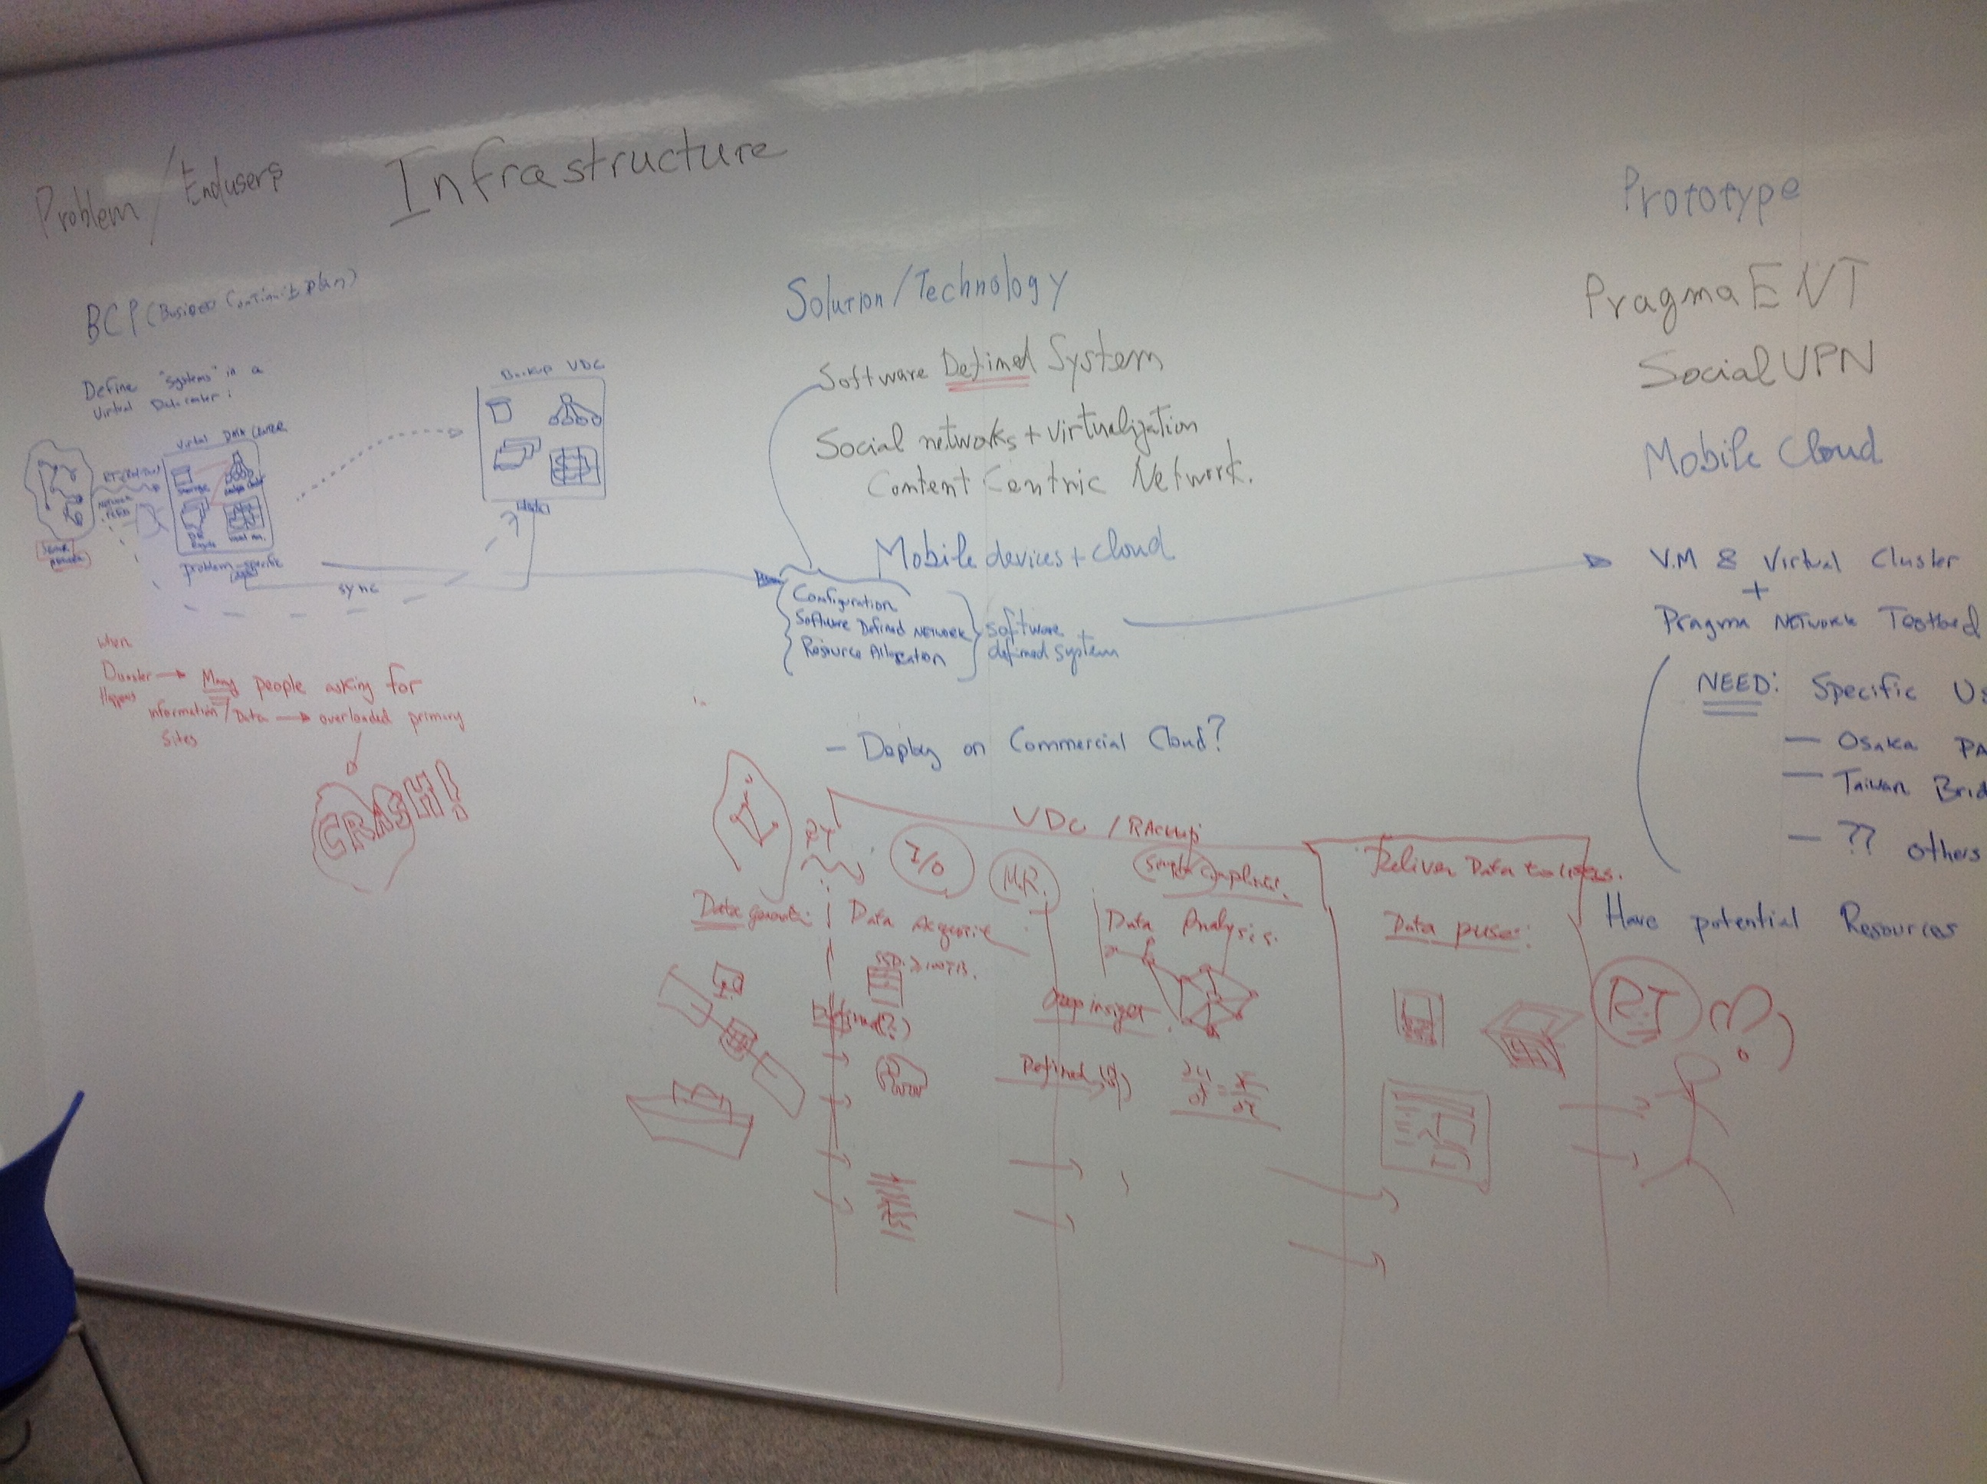

Migration of a Data Center (part 1)

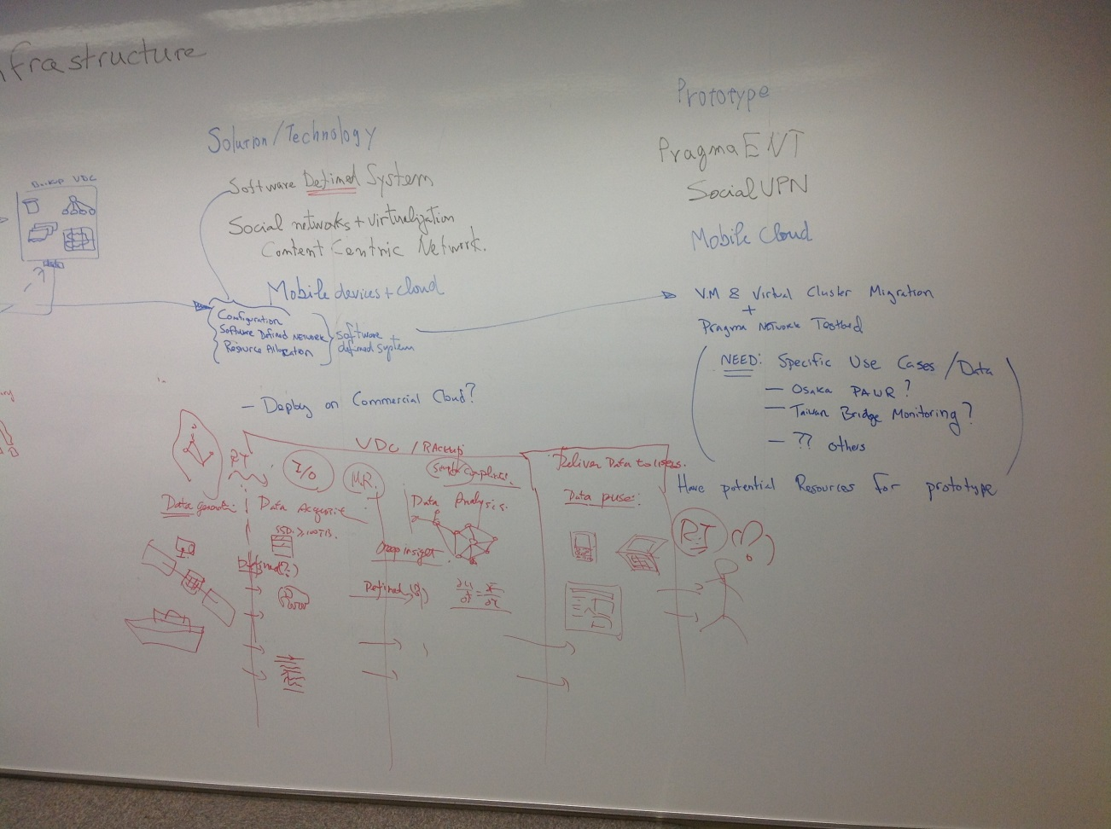

Migration of a Data Center (part 2)

**Meeting Structure and Participant Composition**

There were 22 attendees of the meeting. The meeting schedule and structure allowed for a great deal interaction. Notable about the interactions:

* The small number of participants allowed for people to know everyone at the meeting. It was helpful that nearly half of the participants are regularly engaged in PRAGMA, and many others were known to at least one of the PRAGMA members.
* There were different expertise present on the technology side, and a few people who had closer experience with disaster management.
* Two entire walls of white boards allowed for much real-time sharing of ideas about specific topics and sketching out ideas
* Breakout sessions (two sessions, different groups and topics) allowed for smaller groups to meet
* Critically, many junior members were asked to chair the breakout sessions, giving them an opportunity to shape discussions.

Comment for future meetings:

* We need to do more to attract women participants. At this meeting only three participants of the 22 where women.
* Also, we need to plan to have more people who have been directly involved with disaster management at a meeting.

**Participants**

See ????

**References**

Share locations

* Shared comments during meeting: <https://docs.google.com/document/d/1ndNvIeiOxmPt5akUuU8VU88-eWXvsaIX9I1pPFXFQ_A/edit>
* Location of documents presented or developed at the meeting: [https://drive.google.com/folderview?id=0By21h455-HRQUHc1QXB6VXRUTlE&usp=drive_web#](https://drive.google.com/folderview?id=0By21h455-HRQUHc1QXB6VXRUTlE&usp=drive_web)

Other References

Improving Disaster management, the role of IT in Mitigration, Preparedness, Response and Recovery (2007). The National Academies Press. <http://www.nap.edu/download.php?record_id=11824>

A UNEP Report: Early Warning Systems: A State of Art Analysis and Future Directions (2012) <http://na.unep.net/siouxfalls/publications/early_warning.pdf>.

Japan International Cooperation Agency: Water Resources and Disaster Management

<http://www.jica.go.jp/english/our_work/thematic_issues/water/>

Disaster management Theme

<http://www.earthzine.org/disaster-management-theme/>

<http://www.earthzine.org/wp-content/uploads/2011/03/Figure-2cropped.jpg>

International Centre for Water Hazard and Risk Management

<http://www.icharm.pwri.go.jp/about/about.html>

Disaster Management Policy Program

<http://www.grips.ac.jp/cms/wp-content/uploads/2012/05/dmp_pamphlet.pdf>

World Water Forum 5

<http://www.worldwatercouncil.org/fileadmin/wwc/World_Water_Forum/WWF5/Water_and_Disaster.pdf>

The Mirror of Ibnu Sina

<http://nazshua.blog.com/2010/12/10/emergency-management-preparedness-response-and-recovery/>

NRC 2013: The Resilience of the Electrical Power Delivery System in Response to Terrorism and Natural Disasters (Division of Engineering and Physical Science)

“The question…..is whether events like Sandy can create a teachable moment for those parts of the country that have not yet had extensive experience with extreme weather events”

<http://www.nap.edu/catalog.php?record_id=18535>